
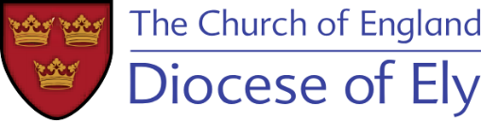
Team Administrator
Lordsbridge Team of Churches
We are seeking a highly organised, skilled person to serve as Team Administrator for the Lordsbridge Team of Churches. The Team Administrator has a pivotal role in the smooth running of the benefice, supporting and enabling the Team’s varied ministries.
The Lordsbridge Team is made up of 11 Church of England parishes just to the West of Cambridge. It is led by the Rector and 3 Team Vicars and is supported by a wide group of other ministers.
We are looking for someone who is:
- Committed to the vision of The Lordsbridge Team.
- Enthusiastic, energetic and possessing a good sense of humour.
- Excellent with detail and has strong organisational skills.
- Able to work on own initiative and manage a busy workload.
- A completer/finisher, implementer, team player.
- Someone who is a good relationship builder and communicator.

For the full job description and an application form, please go to www.lordsbridge.org
Applications should be returned to revdclarecoates@gmail.com
Deadline for applications: 12noon, Friday 20th March 2026.
Interviews will be on Tuesday 24th March 2026.

